Social Studies 20-1

Related Issue I

To what extent should nation be the foundation of identity?
Written Response

SENIOR HIGH SCHOOL
Fort Saskatchewan 780 992 0101
Sherwood Park 780 464 1899
Vegreville 780 632 7998

Part 3: Source Analysis

Examine all three sources and complete the assignment (p..4)

Source 1

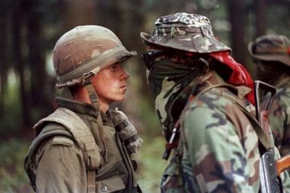

This famous photograph is one of the most enduring images of the Oka crisis. It shows soldier Patrick Cloutier nose to nose with a masked protester Brad Larocque.

Source 2


Image accessioned on October 3, 2012 from http://www.cbc.ca/news/canada/montreal/
story/2012/07/01/montreal-closures-canada-day.html

Source 3
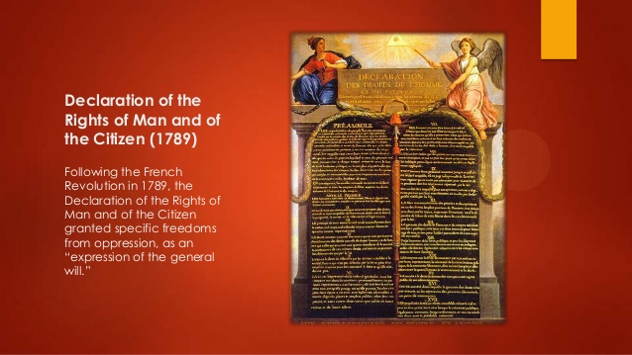


Source Interpretation
Examine all three sources and complete the following assignment.

Assignment
Examine each source.

Write a response in paragraph form in which you must:

- interpret each source to demonstrate your understanding of how
each source is related to your nation as the foundation of identity

AND

- explain one or more of the relationships that exist among
all three sources

Reminders for Writing

- Organize your response

- Proofread your response

20-1 Score Sheet for Source Analysis

Criteria | Score |  |  |  |  |  | Total
Interpretation of Source | E | Pf | S | L | P | INS | /12
Identification of Relationships | E | Pf | S | L | P | INS | /6
Communication | E | Pf | S | L | P | INS | /2

E - Excellent: sophisticated/precise, accurate/perceptive, precise/skillful
Pf - Proficient: sound/capable, clear/purposeful, controlled/effective
S - Satisfactory: straightforward, generally identified, conventional/basic
L - Limited: vague/simplistic, illogical/incomplete, simplistic/ineffective
P - Poor: minimal/inaccurate, minimal/tangential, inaccurate/uncontrolled
INS- Insufficient: does not contain discernible attempt to address the assignment or responses that are too brief to assess in one or more categories

Social Studies 20-1
- Three sources are provided for interpretation and analysis (cartoons, charts, diagrams, maps, graphs, readings, quotes, photographs, paintings, posters, etc.), typically two text and one visual or vice versa.
- Two distinct skill-based tasks are required:

- Interpret each source to identify their ideological perspective(s), and explain how each source LINKS to:

nationalism/contending loyalties/ understandings of nation and nationalism: relationship to land, geographic, collective, civic, ethnic, cultural, linguistic, political, spiritual, religious, patriotic and or nationalism as an identity.

2) Identify and explain one or more relationship(s) that exist among the sources.
- You must respond in paragraph form and address both tasks.
- This does not mean it must be organized or written in a conventional intro/body/conclusion (essay) format, but you may choose this approach.
- Here are a two effective approaches:

Approach I (3-5 paragraphs) | Approach II (3-5 paragraphs)
- Write three paragraphs in which you interpret each of the 3 sources by identifying and explaining the perspective(s) presented, AND explain how each is the linked to nationalism.  - Write a fourth (and/or fifth) paragraph in which you explain one or more relationships that exists among the three sources. | - Write an introduction in which you generally describe the relationship(s) that exist among the sources.  - Write a body paragraph (or split the body into 3 paragraphs) in which you write about each of the three sources by identifying and explaining the perspectives presented and discussing their links to nationalism.  - Write a conclusion in which you summarize and reinforce your main points.

Evaluation
Your response will be evaluated in THREE scoring categories (total of 20 marks):
1) Interpretation of Sources 12 marks (4 marks/source)
2) Relationships 6 marks
3) Communication 2 marks

